Erratum: Title of the Original Article

Taro Shinku, a, † Yoshio Hyomen b, ‡

a *Department of Advanced Physics, University of Hongo, 5-25-6 Hongo, Bunkyo-ku, Tokyo 113-0033, Japan*

b *Department of Chemistry, Institute for Vacuum and Surface Science, 2-12-1 Ookayama, Meguro-ku, Tokyo 152-0033, Japan*

† *Present address: Department of Electrical Engineering, University of Hongo, 5-25-6 Hongo, Bunkyo-ku, Tokyo 113-0033, Japan*

‡ *Corresponding author: tshinku@ee.u-hongo.ac.jp*

Original Article: e-J. Surf. Sci. Nanotechnol. Vol. **, pp. **−** (20**)

An erratum article is published in a single column style. The tile of the erratum article should be composed of “Erratum:” followed by a title of the original article. Information of the original article (a volume number, page numbers, and a published year) should be provided between the corresponding author’s e-mail address and the body of the manuscript. The body of the manuscript is not necessarily sectionalized, but it’s authors’ choice to do so.

Figures and/or tables, if there are, should be inserted between the body of the manuscript and the reference section. A use of a text box to attach figures or tables is easier. The size of the text box should be 86 mm or 182 mm in width.



Figure 1: Times New Roman with 9 points should be used for figure captions.

References

[1] A. K. Geim and K. S. Novoselov, Nat. Mater. **6**, 183 (2007).

https://doi.org/10.103/nmat1849

[2] C. Liu, I. Matsuda, R. Hobara, and S. Hasegawa, Hyomen Kagaku **12**, 702 (2006) (in Japanese).

https://doi.org/10.1380/jsssj.27.702

[3] R. Su, R. Bechstein, L. Sø, R. T. Vang, M. Sillassen, B. Esbjornsson, A. Palmqvist, and F. Besenbacher, J. Phys. Chem. C **115**, 24287 (2011).

https://doi.org/10.1021/jp2086768

[4] S. Hüfner, *Photoelectron Spectroscopy* (Springer-Verlag, Berlin, Heidelberg, 2003) Chap. 4.

https://doi.org/10.1007/978-3-662-09280-4

[5] H. Yamada, in; *Noncontact Atomic Force Microscopy*, edited by S. Morita, R. Wiesendanger, and E. Meyer (Springer-Verlag, Berlin, Heidelberg, 2002) p. 193.

https://doi.org/10.1007/978-3-642-56019-4

[6] J. Fujii, in: *Compendium of Surface and Interface Analysis*, edited by The Surface Science Society of Japan (Springer Nature, Singapore, 2018) p. 707.

https://doi.org/10.1007/978-981-10-6156-1_114

[7] M. Luo, *An STM Study of Molecular Self-Assemblies on Cu (111): Structure, Interaction, and Effects of Confinement*, Ph. D. thesis, University of California-Riverside, 2012.

[8] J. R. Morales-Cifuentes and T. L. Einstein, APS March Meeting (Baltimore, 2013) M6.00007.



All articles published on e-J. Surf. Sci. Nanotechnol. are licensed under the Creative Commons Attribution 4.0 International (CC BY 4.0). You are free to copy and redistribute articles in any medium or format and also free to remix, transform, and build upon articles for any purpose (including a commercial use) as long as you give appropriate credit to the original source and provide a link to the Creative Commons (CC) license. If you modify the material, you must indicate changes in a proper way.

Published by The Japan Society of Vacuum and Surface Science

Table 1: Parameters used in the simulation at *hν*1st = 700 eV.

Figure 1: Normal-emission spectra of the Cu-covered ZnO(0001)-Zn surfaces at various Cu coverages. The incident photon energy was 170 eV. In the inset, the integrated intensity of the Zn 3p peak is plotted by dots against the Cu coverage.

Requested size: single-column figure

(optional)

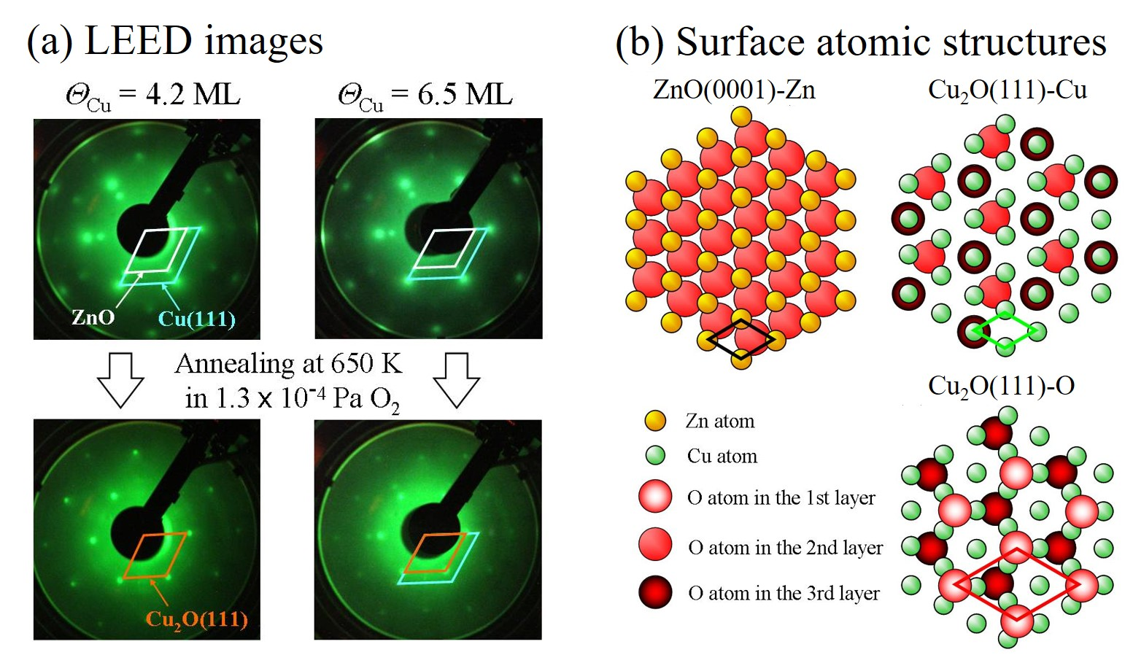

Figure 2: (a) LEED images of the Cu-covered ZnO(0001)-Zn surfaces (Cu coverages of 4.2 and 6.5 ML) and their oxidized surfaces. The primary energy of the incident electron beam was 143 eV. (b) Schematic models of the bulk-terminated surfaces; ZnO(0001)-Zn, Cu2O(111)-Cu, and Cu2O(111)-O.

Requested size: two-column figure

(optional)